**CST-305: Project 8- Numerical Integration**

Jordan Scott and Angel Velazquez

Grand Canyon University

CST-305: **Principles of Modeling and Simulation Lecture & Lab**

Ricardo Citro

April 28, 2024

**CST-305: Project 8 – Numerical Integration**

**Responsibilities:**

Jordan and Angel were responsible for working on the code and the math work while verifying each other’s work.

**System Performance Context:**

Using the Riemann Sum method, we can determine the download rates of files from an internet server by analyzing the time intervals.

**Specific Problem Solved:**

The particular challenge addressed involves creating a tool capable of computing the Riemann integral of a function. Furthermore, the tool is utilized to calculate the volume of data transmitted across a network within a media server stream.

**Mathematical Approach:**

Let f(x) be a function of x defined on an interval I: . Let I be divided into n subintervals and call , the width of the kth subinterval, then

As the number of subintervals increases in that the largest subinterval approaches 0, we can say

The limit is the Riemann Integral of f(x) over I, however, if the limit doesn’t exist, then f(x) is not the Riemann Integral over I.

**Implementation in Code:**

To implement this in code, we would use numpy and matplotlib libraries. First we define our function. After defining our function for the problem we next define the function to calculate the Riemann sum using the midpoint method. Next we initialize our parameter for the Riemann. Then we calculate the Riemann sum. Finally we plot it on a graph. For part 2, we only change initialize parameter and integrated function to make the problem.

**Part 1:**The instructor will assign you a continuous function over the interval *[a, b]*, which you will partition into subintervals of length . You will then approximate the value you want to find as with *ck* a point in the *k*th subinterval. Write a definite integral to express the limit . Finally, evaluate the integral numerically over the given interval.

Write a computer program that performs the numerical integration, using appropriate packages for Python.

1. Graph The function over the given interval . Partition the interval into four subintervals of equal length. Then add to your sketch the rectangles associated with the Riemann sum , given that is the (a) left-hand endpoint, (b) righthand endpoint, (c) midpoint of the subinterval. (Make a separate sketch for each set of rectangles.)

1. For the function over the interval , find a formula for the Riemann sum obtained by dividing the interval into n equal subintervals and using the right-hand endpoint for each . Then take a limit of these sums as to calculate the area under the curve over .

1. This question is worth 16 points and part of additional items in rubric.
   1. Find the Riemann sum from the definitive integral.

Write a Python code using the necessary libraries to plot the general solution with the highest granularity.

* 1. For the function a formula for the Riemann sum obtained by dividing the interval into equal subintervals and using the right-hand endpoint for each . Then take a limit of these sums as n→∞ to calculate the area under the curve over

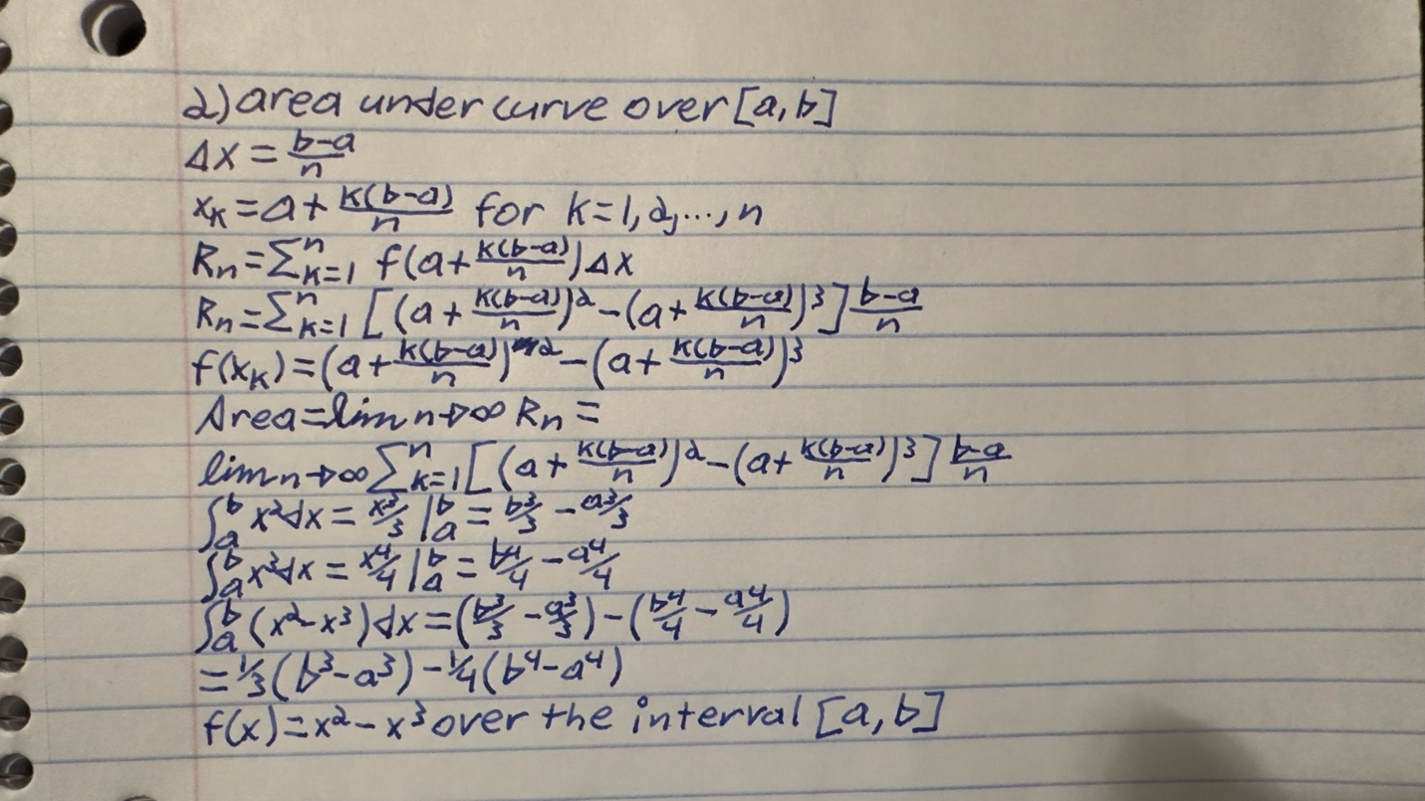

**Part 2:**A media server streams data at a varying rate. The rate (megabytes per second) at which the server operates is recorded at 1-minute intervals for 30 minutes. Locate a content server on the Internet that stores large files and perform several downloads. As you download files, record the download rates (Mbps), and store the results in a table with 30 entries (30 min, 1-minute intervals). Define a function *R(t)* to represent the download rate over time *t* that is continuous over the interval *[0, 30]*. Use the software tool you developed in Part 1 to numerically calculate the amount of data downloaded over the duration of the experiment. Output the value and explain its meaning.

Data:

|  |  |
| --- | --- |
| Time (min) | Download Rate (Mbps) |
| 0 | 5 |
| 1 | 7.3 |
| 2 | 9.8 |
| 3 | 12.5 |
| 4 | 15.4 |
| 5 | 18.5 |
| 6 | 21.8 |
| 7 | 25.3 |
| 8 | 29 |
| 9 | 32.9 |
| 10 | 37 |
| 11 | 41.3 |
| 12 | 45.8 |
| 13 | 50.5 |
| 14 | 55.4 |
| 15 | 60.5 |
| 16 | 65.8 |
| 17 | 71.3 |
| 18 | 77 |
| 19 | 82.9 |
| 20 | 89 |
| 21 | 95.3 |
| 22 | 101.8 |
| 23 | 108.5 |
| 24 | 115.4 |
| 25 | 122.5 |
| 26 | 129.8 |
| 27 | 137.3 |
| 28 | 145 |
| 29 | 152.9 |
| 30 | 161 |

*R*(*t*)=*at*2+*bt*+*c*

*R(0)= a(0)*2+*b(0)*+*c=5.0 c=5*

*R(1)= a(1)*2+*b(1)*+*c=7.3*

*R(2)= a(2)*2+*b(2)*+*c=9.8*

*a*+*b*+*5=7.3*

*4a+2b+5=9.8*

*(4a-a)+(2b-b)+(5-5) = (9.8-7.3)*

*3a+b=2.5*

*b= 2.5-3a*

*a + (2.5-3a)+5 =7.3*

*-2a+7.5=7.3*

*-2a=-0.2*

*a= 0.1*

*b=2.2*

*R*(*t*)=*0.1t*2+*2.2t*+*5*

*This work is also shown on paper and will be in the folder. We would also include an excel file for the data.*

Flowchart:

